SAP 1 – Materials Management
MGIS 4580 – Fall 2023 DELIVERABLE

Check Initial Inventory
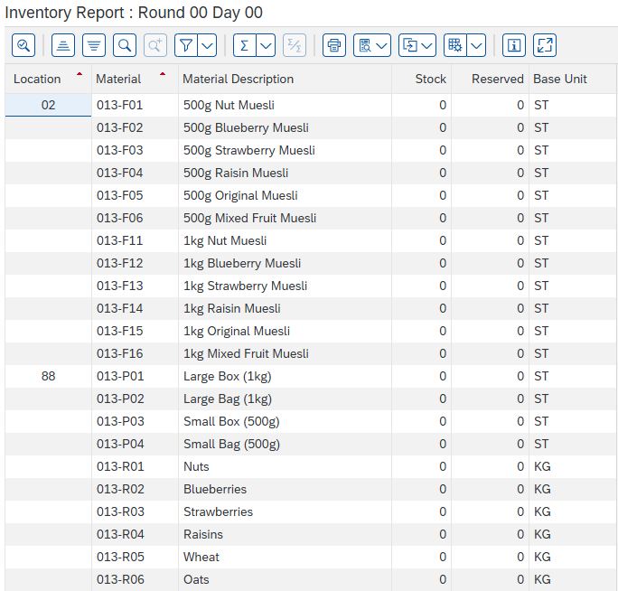

Create Forecast
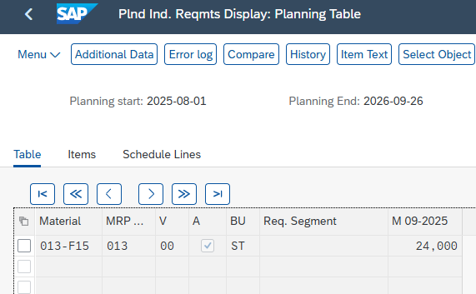

Run MRP
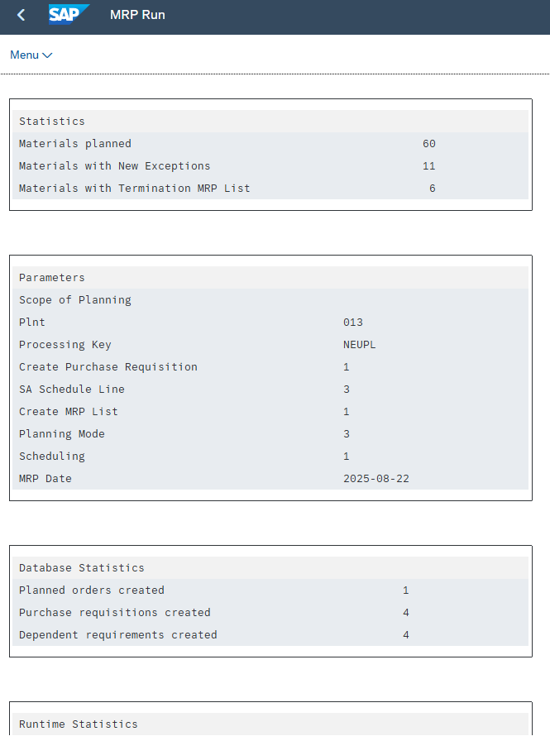

View Purchase Requisitions
